|  |
| --- |
| COLLEGE OF MANAGEMENT & INFORMATION TECHNOLOGY  **BACHELOR IN INFORMATION TECHNOLOGY**  **SaauG.Com**    **Final Year Project**  **As part of the Degree BIT**  **Academic Year 2012**  **Name: Amir Shrestha**    **Year/ Semester: III Year /V Semester**  **LCID: LC00017000502**  **Project Supervisor: Saroj Poudel** |

**TABLE OF CONTENTS**

ABSTRACT............................................................................5

Chapter 1: Introduction ..................................................................6

Chapter 2: Background and History...............................................6

Chapter 3: Aim and objectives........................................................7

Chapter 4: Boundaries of project ...................................................8

Chapter 5: Importance of E commerce...........................................8

Chapter 6: PROBLEMS OF ONLINE SHOPPING.......................9

Chapter 7: System Description.....................................................10

Chapter 8: Conclusion ..................................................................16

**TABLE OF FIGURE**

Figure 1: Index page.....................................................................10

Figure 2: Product Category Carousel............................................11

Figure 3: Products Model.............................................................11

Figure 4: Events Index..................................................................12

Figure 5: Blog Events Model........................................................12

Figure 6: Login Form....................................................................13

Figure 7: Signup Page...................................................................12

Figure 8: Order Cart......................................................................14

Figure 9: Default Django Admin..................................................14

**Acknowledgment**

I am thankful to the Lincoln University College, for providing me this opportunity. Also allow me to express the deepest gratitude to the IT Department of Texas College of Management and IT for providing this opportunity to enhance my skill. I would also like to thank Mr. Suman Thapaliya for guidance on how to start and complete our project. This project had taught me a lot regarding my subject matter. Our supervisor helped us in different obstacles during our project creation and helped us how to think for project creation and completion and I am thankful for that.

**Plagiarism Declaration**

I confirm that the enclosed written work along with my application code is entirely my own. I also declare that wherever I had copied, paraphrased, summarized by providing full credit to the respective author. More than this if any other material, word, sentences found will be just a mistake. I had tried to be full open and honest regarding my project.

**Abstract**

Electronic Commerce is process of doing business through computer networks which is the most visible business used in today's world. The main aims of an e-commerce site are to buy and sell goods online with in a click of a button. Also blogging is a wonderful way to build your audience and generate more traffic and sales for your business.

Likewise, this project deals with developing an e-commerce website for Online Product Sale and blogging events of sales/events as ecommerce marketing strategy to increase traffic. It provides the user with a catalog of different product available for purchase in the store. To facilitate online purchase a shopping cart is provided to the user. The system is implemented using a 3-tier architecture approach, with a backed database (SQLite), a middle tier of web framework called Django (Python framework), and a web browser as the front-end client. To develop an e-commerce website, several Technologies must be studied and understood. These include multi-tiered architecture, server and client-side scripting techniques, implementation technologies such as Python, JavaScript, Bootstrap, HTML, Django, jQuery, Relational database (SQLite using Django ORM).

This is a project with the objective to develop a basic website where a consumer is provided with a shopping cart application along with blog and to know about the technologies used to develop such an application. This document will discuss each of the underlying technologies to create and implement an e-commerce website. With that reference “SaauG.com” has been developed using Python programming language.

**Chapter 1:Introduction**

SaauG.com is a mini e-commerce project with blog system integrated with it for Oline shopping and events feeds.

The purpose of this system is that customers can buy products using online technology that consists of carousel of products category wise and cart that holds the product that to be purchased. A user can easily add, remove to its cart and checkout if they want to buy it.

A registered user as well as an unregistered user can easily checkout the product they require. Also, on the agenda is designing an online shopping site to manage the items in the shop and help customers purchase them online without having to visit the shop physically.

Along this there are many more e-commerce related websites like daraz.com, foodmandu.com, amazone.com etc. but they don't have any blog system with them as it increases traffic in ecommerce market.

**Chapter 2: Background and History**

The history of ecommerce started over 40 years ago, when the introduction of early technology like Electronic Data Interchange (EDI) and teleshopping in the 1970s paved the way for the modern-day ecommerce store as we know it today.

The history of ecommerce is closely intertwined with the history of the internet. Online shopping became possible when the internet was opened to the public in 1991. Amazon was one of the first ecommerce sites in the US to start selling products online and thousands of businesses have followed since.

The convenience, safety, and enjoyable user experience of ecommerce have improved exponentially since the inception of online shopping. In his article, we will discuss some of the key players and milestones of ecommerce.

<Reference: miva.com>

**Chapter 3: Aim and objectives**

What you hope to achieve at the end of project?

Aim: Make user familiar about use of internet for trading purpose especially buying online and numbers of events that's Helding on the daily basis.

Steps to be taken to achieve desirable outcomes?

Objectives:

• Data sets will be extracted according to product category,

• Provide feeds of events,

• User friendly, as all user can use it easily,

• Identify necessary changes that can be made on future,

• End users' satisfaction,

• Effective and simplicity,

• Complete project at the given deadline.

**Chapter 4: Boundaries of project:**

For e-commerce:

End-user Product are categorized,

Buy products online,

Search for required product,

For Events blog:

gets list of events on their events feed page,

Mega Events

**Chapter 5: Importance of E commerce**

For entrepreneurs in 2021 and the years to come, e-commerce is the golden pot of opportunities needed for a successful business.

It has grown to be invaluable for businesses today. With digitization spreading and modern technologies emerging, entrepreneurs need to invest in e-commerce development to survive the competitive market.

It is essential for a positive ROI and will help in acquiring not just local customers but also individuals on the other side of the world. Plus, with the increasing use of smartphones, tablets, laptops, and other portable devices, an e-commerce website is immensely beneficial for your marketing and branding.

Additionally, in current pandemic times, where social distance is vital, online businesses can operate from the safety of one's home. So, you do not need to invest in an office space or decide for employees' workspaces, saving your time and money.

That said, if you want to know more about e-commerce and its importance today, then you are in the right place. In the blog, we will discuss what eCommerce is, its role in the present-day market, its types, benefits, and more.

<Reference: yourstory.com>

**Chapter 6: PROBLEMS OF ONLINE SHOPPING**

In current market, as e-commerce websites are getting bigger and bigger, they are enhancing their features ass well which therefore makes end-user bit confuse to use it, especially in context of Nepal where most of the people just started using electronic devises. So, I have made this project as simple as i can considering the user of Nepal.

As it is said that no business can run for a long run without proper marketing strategy, e-commerce site today just focusses on buying and selling of products. But in my project, I have added a blog system that gives the feeds of especial occasion / events that are going to be held which will automatically promote business.

**Chapter 7: System Description**

Firstly, any system developed are to be used in different devices that come with different shape and size. So, we should be sure that our system is abatable for all devices. Therefore, we must make a responsive site. Here, SaauG.com is developed using various web Technolgies like Django, Html, CSS, JavaScript, jQuery, Bootstrap, Goggle Font.

Below, picture shows the file structures of our project.

**Home page**

Home page where use can see and purchase the products.

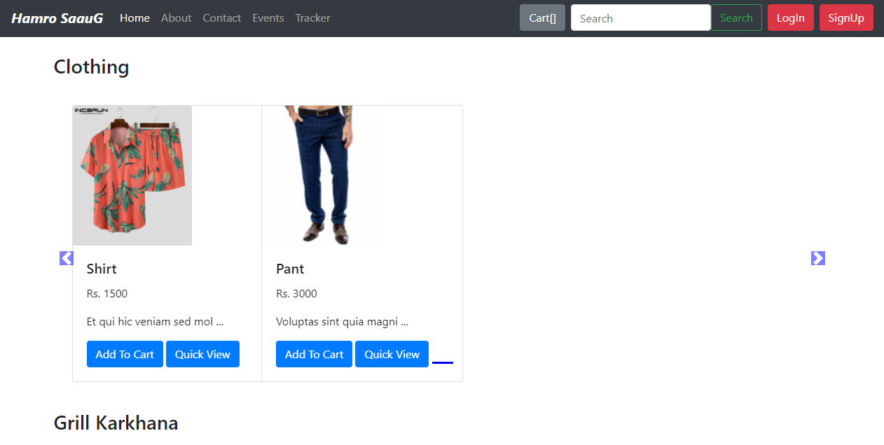

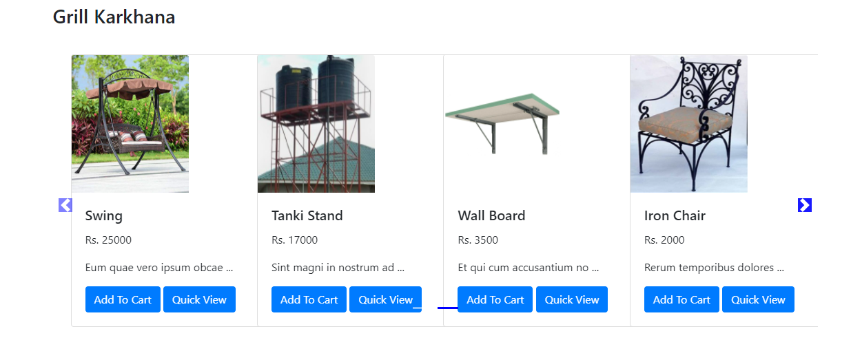

**Products Model**

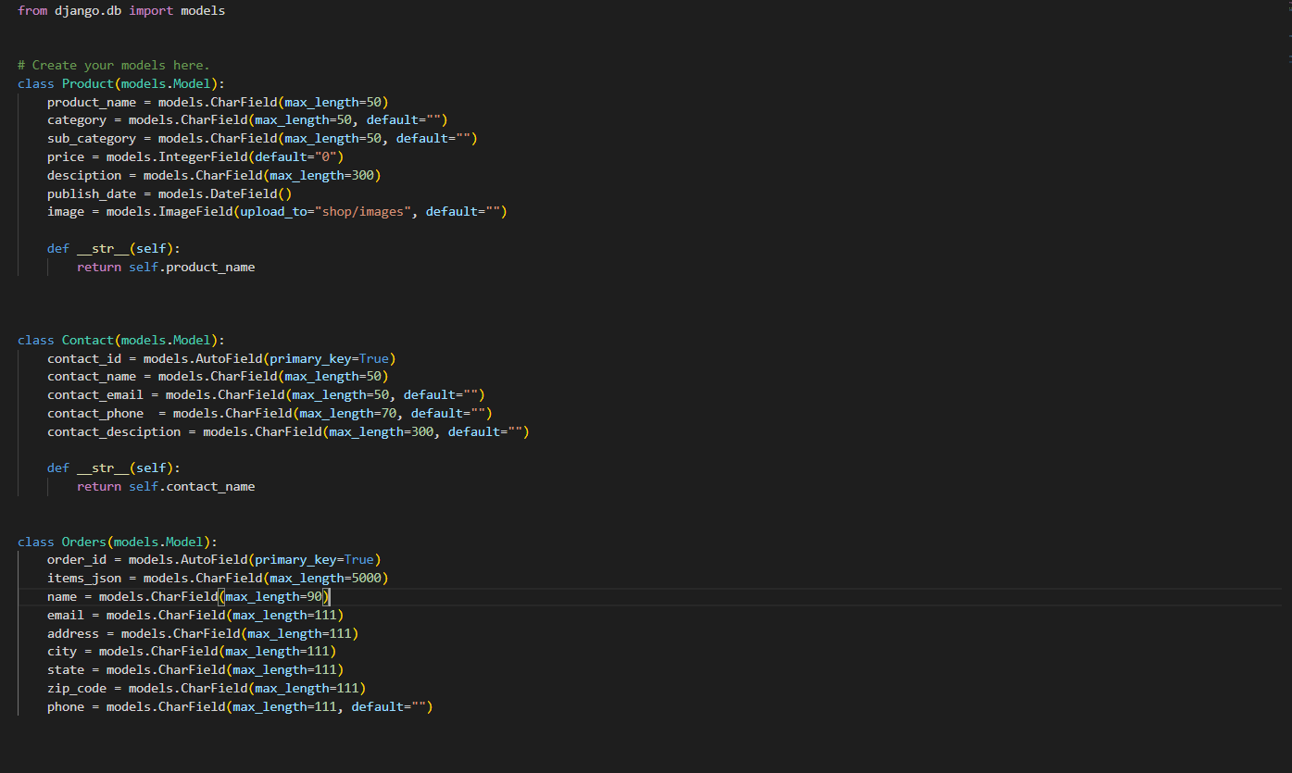

**Events page**

Events page where events feeds can be seen.

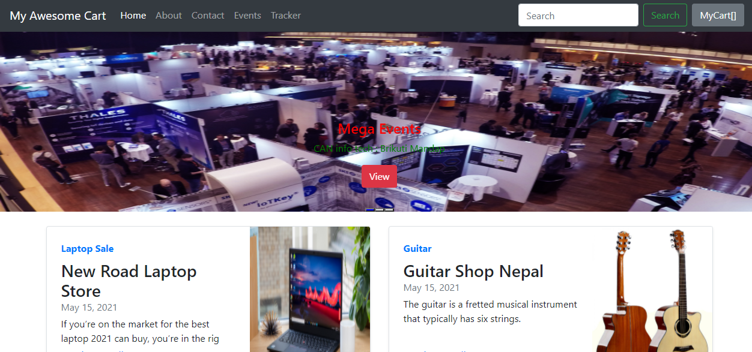

**Blog Events Model**

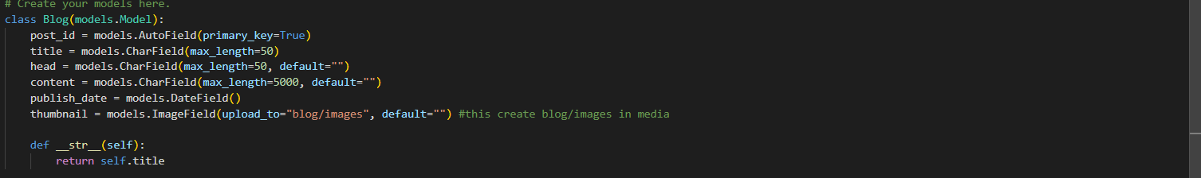

**Login page**



**Signup page**

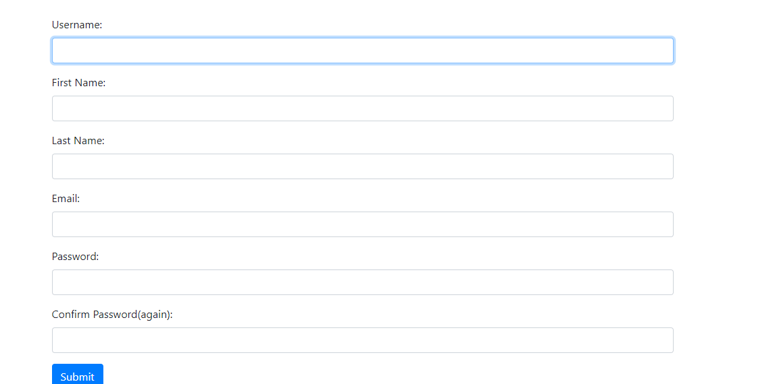

**Order Cart page**

Cart page which consists of all choose products.

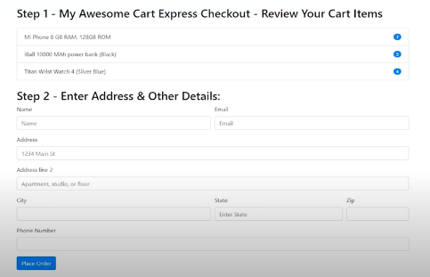

**Admin page**

Default admin page provided by Django to access admin portion.

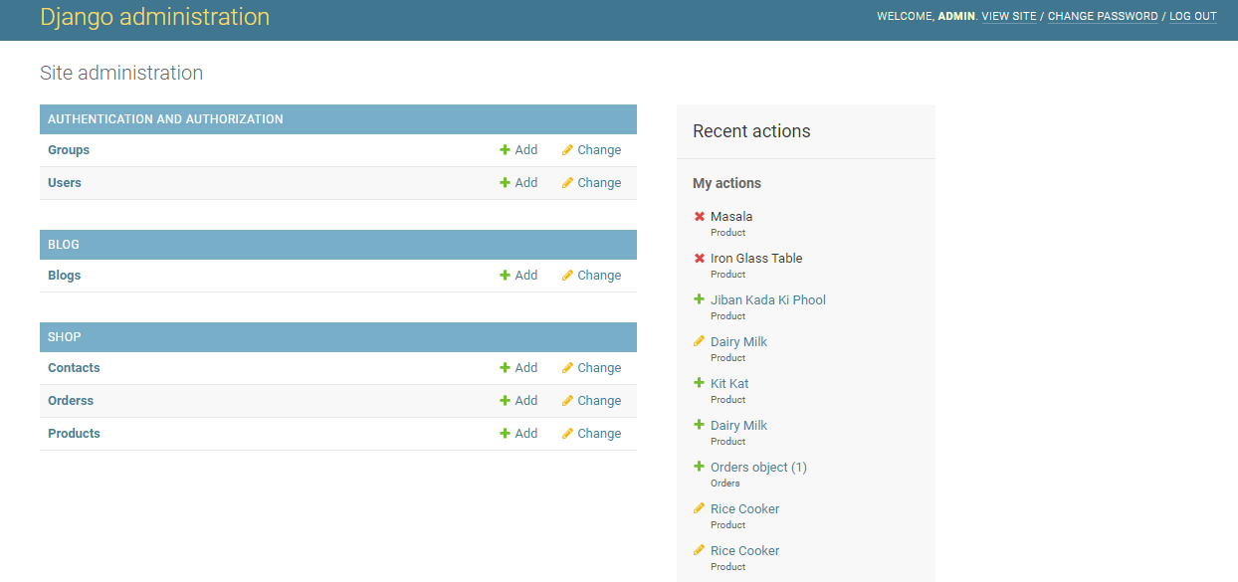

**Chapter 1: Conclusion:**

Therefore, this project as simple as I can considering the user of Nepal for online buying of products integrated with Special Occasion System is a system, that gives use feeds about every occasion or event host by different parties, solving problem for many people who gets confuse during some occasion, gets bored, etc. and solves problem of many businesses' organization regarding customer availability. (Somehow decreases advertisement expenses too)

**Thank you!**